Crypt-Arithmetic Problem in Python
Aim:
To implement a Python program to solve a Crypt-Arithmetic problem using backtracking in Artificial Intelligence.
Objective:
- Implement the Crypt-Arithmetic problem in Python.
- Assign unique digits to letters using backtracking.
- Verify the arithmetic equation for a valid solution.
- Understand the application of Constraint Satisfaction Problems (CSP) in AI.
Algorithm:
- Start the program.
- Define the Crypt-Arithmetic equation: SEND + MORE = MONEY.
- Identify all unique letters in the equation: S, E, N, D, M, O, R, Y.
- Generate all possible permutations of digits (0–9) for the eight unique letters.
- Assign one unique digit to each letter.
- Check that the leading letters S and M are not assigned the digit 0.
- Convert the words into their corresponding numeric values using the assigned digits:
- SEND
- MORE
- MONEY
- Verify whether the equation SEND + MORE = MONEY is satisfied.
- If the equation is true:
- Display the digit assigned to each letter.
- Display the values of SEND, MORE, and MONEY.
- Stop the program.
- Otherwise, discard the current digit assignment and generate the next possible permutation.
- Repeat Steps 5–10 until a valid solution is found or all possible assignments have been checked.
- If no valid assignment exists after checking all permutations, display "No solution found."
- End the program.

Flowchart:

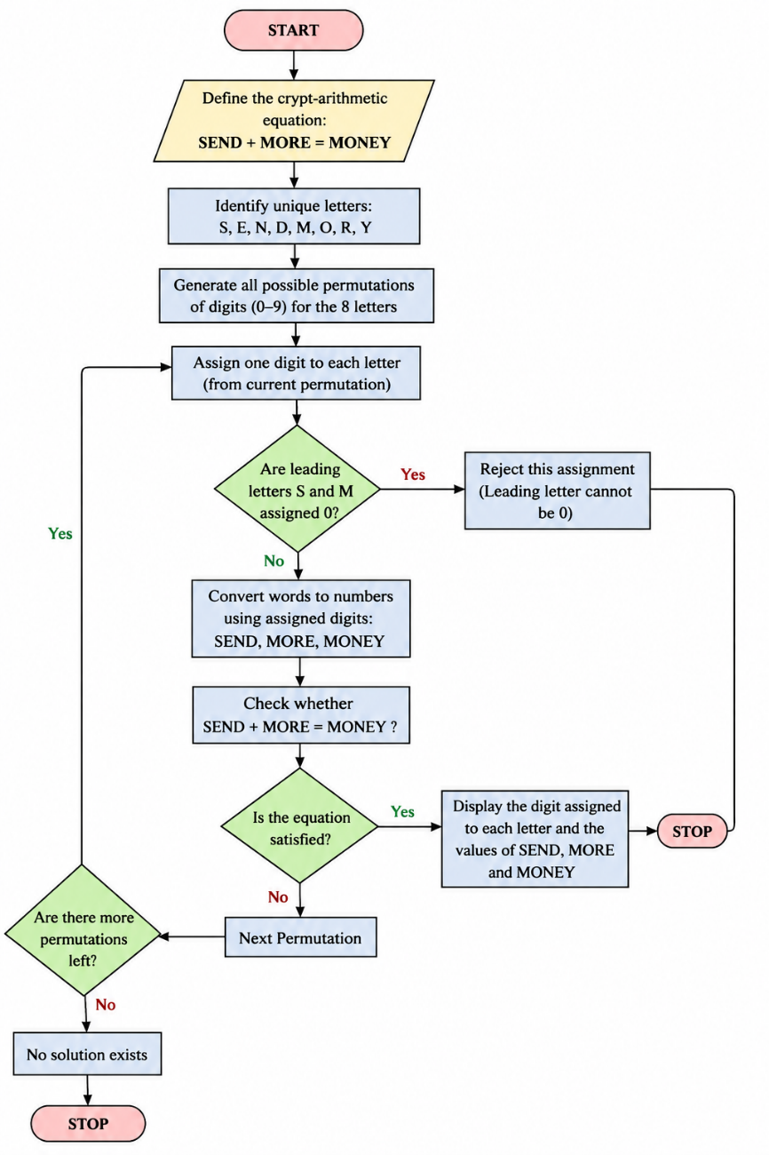
Python Code:
from itertools import permutations
def solve_cryptarithmetic():
letters = ('S', 'E', 'N', 'D', 'M', 'O', 'R', 'Y')
digits = range(10)
for perm in permutations(digits, len(letters)):
mapping = dict(zip(letters, perm))
# Leading letters cannot be zero
if mapping['S'] == 0 or mapping['M'] == 0:
continue
send = (mapping['S']*1000 +
mapping['E']*100 +
mapping['N']*10 +
mapping['D'])
more = (mapping['M']*1000 +
mapping['O']*100 +
mapping['R']*10 +
mapping['E'])
money = (mapping['M']*10000 +
mapping['O']*1000 +
mapping['N']*100 +
mapping['E']*10 +
mapping['Y'])
if send + more == money:
print("\nSolution Found!\n")
for letter in letters:
print(letter, "=", mapping[letter])
print("\nSEND =", send)
print("MORE =", more)
print("MONEY =", money)
return
print("No solution exists.")
# Main Program
solve_cryptarithmetic()
Sample Output:
Solution Found!
-----------------------
S = 9
E = 5
N = 6
D = 7
M = 1
O = 0
R = 8
Y = 2
-----------------------
SEND = 9567
MORE = 1085
MONEY = 10652
Result:
